Santana – The Game of Love
YAM: piano1 Q22: brass

[INTRO] Begins WITH piano
em7 | DM9 3x
GM7 | Asus4

[VERSE]
em7 | DM9 4x skip on Verse 3
em7 | DM9 | GM7 | Asus4 A so please tell me why
em7 | f#m7 | GM7 | Asus4 A

[CHORUS]
em7 | DM9 3x
em7 | Asus4 A back to verse
[ em7 | DM9 | GM7 | Asus4 A ] 2nd chorus only
then BRIDGE

[BRIDGE]
bm7 | f#m7 | GM7 | Asus4 A you roll me...2:06
em7 | f#m7 | GM7 | A
^^^^^^^^^^^^^^^^^^^^^^^^^^^^^^^ breaks 2:14

- GUITAR SOLO: intro chords 2x
- Go to Verse 3 (with skip)
- CHORUS a cappella 8 bars, use brass
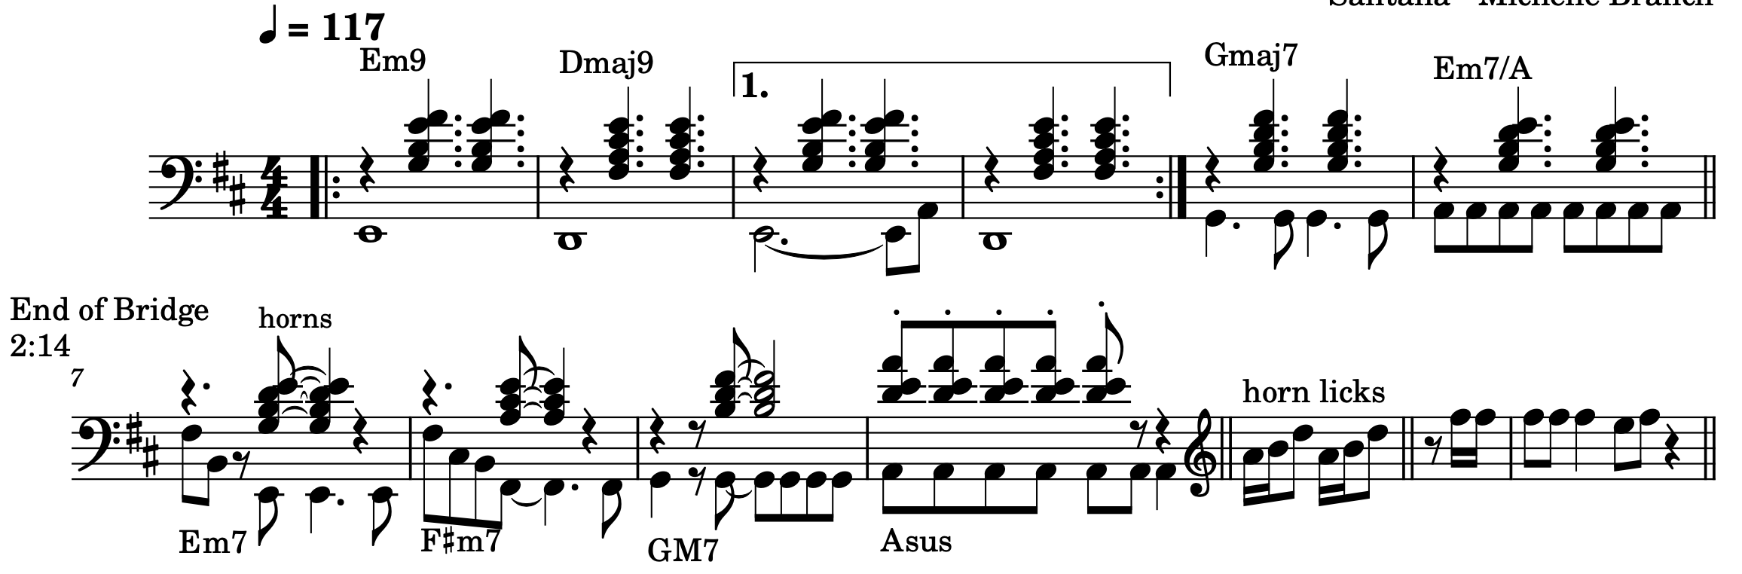
- Intro pattern thru rest of song, use brass

